H infinity homework2

108061578 高振晏

In this homework, we try to plot the state trajectory of a linear stochastic system with sin and cosine external disturbance. We first write down the state-space representation of the augmented system with x and the error of x and x_hat. Then we solve the riccati-like equation which is a BMI, so we separate the BMI matrix into 2 LMI problem and solve them respectively. Also since we want to reach the H2 performance, so we also consider minimizing the effect of the initial state, so then we need to solve the LMI of both H infinity and H2 constraint.

By assuming the initial state to be [10, 20], we minimize the for ρ H infinity andγ for H2. And we get ρ=4008.1 γ=4008.1. Then we use Runge-Kutta 4th method to plot the state trajectory.

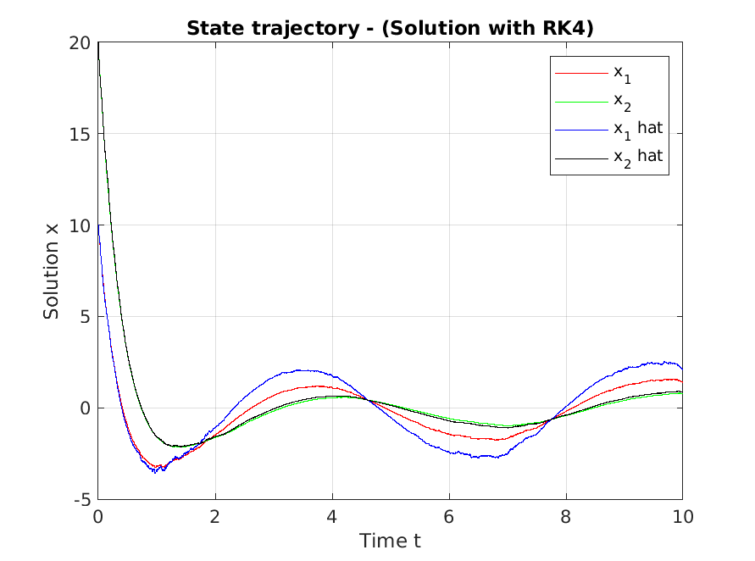

Fig.1 state trajectory with Runge-Kutta.

We can see that due to the smoothing method, the effect of wiener process is not obvious. Also we can see that x1 isn’t tracing very well. The x1_hat is overshoot too much. However, x2_hat is tracing x1 very well.

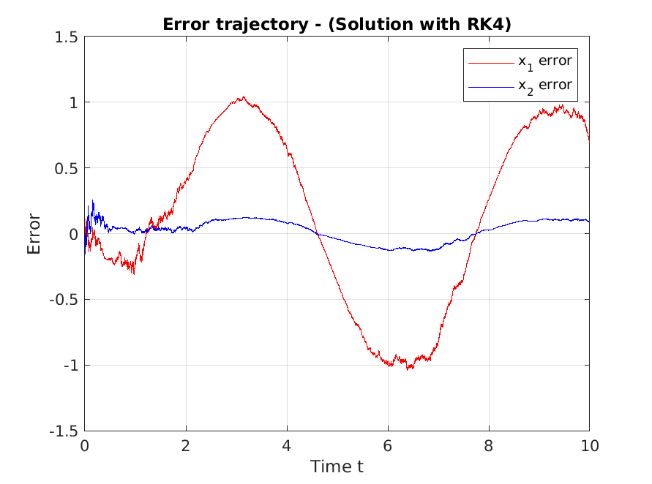

Fig.2 Error trajectory with Runge-Kutta

We can see that the error of x2 is quite small and only fluctuating around zero. However, error of x1 is quite large, and seems to follow the sin wave shape. Since we can see x2 from our output measurement, we can control x2 better and also theρ that we try to minimize is still quite large, so the effect of H infinity is not that obvious.

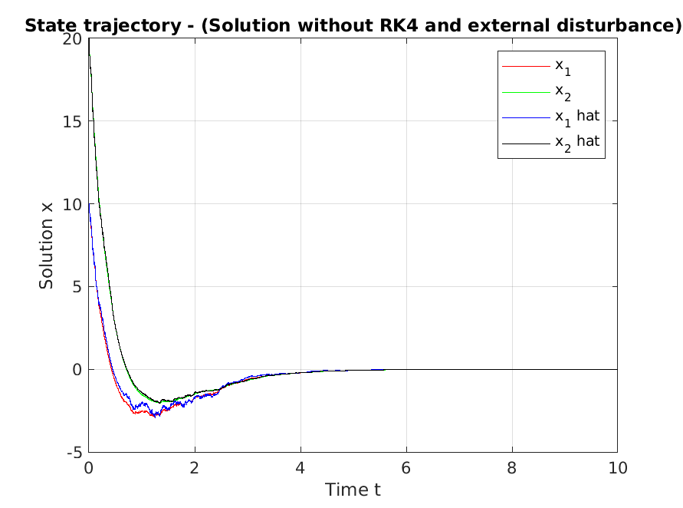

Fig.3 State trajectory without Runge-Kutta and external disturbance.

We can see that since we consider mix H2/H infinity performance, so when we eliminate external disturbance, it can be stable. Also, we can see that without the external disturbance both x1 and x2 can be traced very well. However, since we have largeγso out transient affects quite long. If we only try to minimizeγthe for H2 performance, we may can have very smallγ.

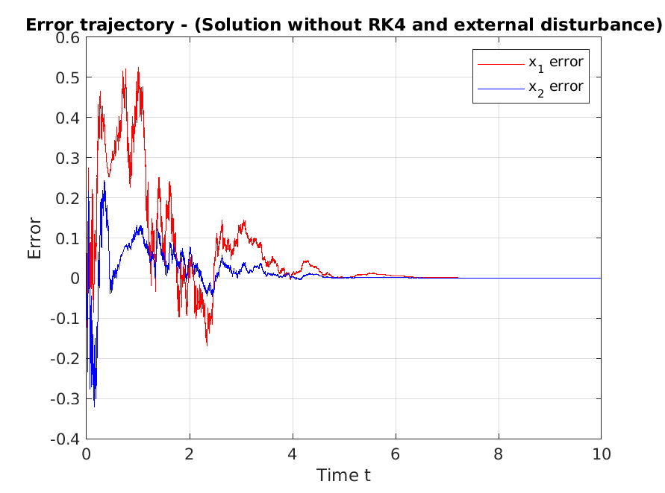

Fig.4 Error trajectory without Runge-Kutta and external disturbance.

We can see that mostly the error is due to the system uncertain (i.e. the wiener process), the uncertainty error tends to reduce to 0 when our system becomes more stable.